Job Analysis
- What is Job Analysis?
  - “a process used to identify the important tasks of a job and the essential competencies an individual should possess to satisfactorily perform the job.” (State of Colorado, 2002, http://www.colorado.gov/dpa/dhr/select/docs/jobanal.pdf).
  - “a wide variety of systematic procedures for examining, documenting, and drawing inferences about work activities, worker attributes, and work context.” (Sackett & Laczo, 2003, p. 21).
  - methods for learning about the tasks involved in doing a job and/or the knowledge, skills, abilities and other characteristics (KSAOs) that a worker needs to have to do the job (or, to do it well), and the context in which a job is performed.
    - From these definitions, you should see that there are two types of job analysis: job-oriented (aka task-oriented or work-oriented) and person-oriented (worker-oriented).
- The purposes of job analysis
  - "... job analysis is to the personnel specialist what the wrench is to the plumber." (Cascio, 1982). It is the “cornerstone of nearly all personnel practices.” (Mitchell, Alliger, & Morfopoulos, 1997).
    - In other words, job analysis is used for nearly everything, including…
  - Job Description: A snapshot communicating the essence of the job.
    - Usually contains information such as job title, summary of job purpose or objectives, and duties and tasks that are done on the job.
    - Among other purposes, job descriptions are important for letting people who don’t do the job know what the job is.
  - Job Specification: Identifying the skills or attributes a worker should have to successfully do a job.
  - Job Classification: Identifying what jobs go together somehow.
    - They may go together for a variety of reasons, for example:
      - Similar tasks carried out.
      - Similar KSAOs needed.
      - Similar lines of authority.
    - Job classification can be important for setting pay, hiring employees, moving employees between jobs.
  - Job Evaluation: Establishing the worth of jobs to employers.
  - Job design and redesign: Deciding what tasks or units of work go together into a single job.
  - Personnel Selection & Firing
    - Job analysis is crucial in identifying the KSAOs that should be looked for in hiring.
  - Training
    - What KSAOs must be taught.
    - What tasks must be learned.
  - Safety
    - Job analysis can identify job tasks that increase accidents and injury. Job analysis can identify working conditions that are dangerous.
  - Ergonomic Design: Knowing what people do on the job helps design equipment to be more efficient and safer.
  - Performance Appraisal
    - Job analysis identifies the dimensions that an employee should be evaluated on.
    - It is also very important to make sure that performance appraisals (and the consequences that come with a bad evaluation) are administered fairly, without discrimination.
      - Aside for general moral & business reasons for doing this, there are legal reasons (see below).
  - Avoiding Discrimination & Defending against Charges of Discrimination
    - When making personnel decisions, it is legitimate to hire/promote/reward people who do the job better, even if certain ‘classes’ of people do not get hired. But to do this, you have to know what the job really entails.
      - Discrimination and Adverse Impact: “Potential unfairness in the treatment of [a] minority group or protected class members.” (From your textbook, p. 405).
        - If a procedure used for making personnel decisions causes a protected group to be more negatively treated than other groups, it has adverse impact.
        - If even so the procedure relates to job performance, then the law does not consider that discrimination.
          - Job Analysis can be used to identify what are necessary parts of the job, and is an important part of establishing the relationship of a procedure to job performance.
      - The Americans with Disabilities Act (ADA) says that employers cannot discriminate against people with disabilities unless they are unable to perform essential functions of the job, even with reasonable accommodations.
        - Essential Function: “Those job duties that are so fundamental to the position that the individual holds or desires that s/he cannot do the job without performing them. A function can be "essential" if, among other things: the position exists specifically to perform that function; there are a limited number of other employees who could perform the function; or the function is specialized and the individual is hired based on his/her ability to perform it.” (From www.eeoc.gov/policy/docs/accommodation_procedures_eeoc.html).
        - Reasonable Accommodations: “Any change in the work environment or in the way things are customarily done that would enable a qualified individual with a disability to enjoy equal employment opportunities.” These accommodations are considered reasonable if they do not cause “undue hardship” on an organization because they are very difficult or expensive for the organization to implement. (Also from www.eeoc.gov/policy/docs/accommodation_procedures_eeoc.html).
- How do different methods of Job Analysis differ from each other?
  - Job Descriptors
    - Job Oriented (task-oriented, work-oriented)
      - focuses on specific tasks needed to do the job.
    - Person-Oriented (worker-oriented)
      - focuses on the knowledge, skills, abilities, aptitudes, attributes, and so on, of individual workers believed necessary to do the job tasks and behaviors successfully. Tries to identify the KSAOs needed for the job.
      - Person-Oriented Job Analysis requires more inferences. It is a bigger leap from observing the job to KSAOs than it is from observing the job to tasks.
  - What level of description is generated?
    - We could describe what someone does on a job at many different levels.
    - A job element means the smallest unit of work that has a clear beginning, middle, and end. Describing things in any smaller unit would require describing the physical actions needed to do it.
      - For example, if we were doing a job analysis on the job police officer, one element would be “dialing the phone.”
        - If we wanted to describe this in any smaller unit, it would be physical: Pick up handset, press numbers, etc.
    - An activity is a group of elements that have a goal of fulfilling some work requirement.
      - For example, an activity for police officers that involves the element “dialing the phone” is “Calling witnesses to ask questions.”
      - A typical job may have more than 100 activities. Complex jobs may require several hundred.
    - A task is a collection of activities that are meant to achieve a specific job objective.
      - For example, a police officer calls witnesses to “obtain information about a crime”.
      - A typical job analysis may have 30 to 100 tasks.
    - A duty is a collection of tasks all directed toward general goals of a job.
      - For example, Homicide Duties.
      - A thorough job analysis might produce 5 to 12 duties for a typical job.
Further Examples of Duties, Tasks, Activities, & Job Elements for the Job of Police Officer
Term | Example
Duty | Traffic Enforcement
Task | Issue Tickets to Violators
Activity | Pull Motorist Over
Element | Switch on Siren and Lights
  - Quantitative or Qualitative?
    - Qualitative involves a verbal, narrative description of the job.
    - Quantitative involves numeric information
      - Could be something like: “Must be able to lift 40 lbs.”
      - But, more often will be something like ratings on scales, for example:
        - Ratings of how important a particular activity or ability is.
        - Ratings of how often or frequently a certain task is done.
  - Who provides information about the job?
    - Subject Matter Experts (SMEs)
      - Job Incumbents
      - Supervisors
    - Others who come in contact with the worker or job.
      - Clients or customers
      - People in other organizational units
    - The Job Analyst
    - Written Sources of Information
      - Existing job descriptions
      - Training Manuals
      - Performance Appraisal Materials
        - But, these may reflect people’s opinions about the job, rather than what the job really involves.
      - Previous job analyses.
  - Methods for obtaining data (See p. 61 in the textbook for advantages and disadvantages).
    - Interviewing Individuals or Group Interviews
    - Questionnaires: Structured or Open-Ended
    - Diaries: The job incumbents keep records of what they do during their working day.
    - Video or audio recording. Physiological recording (for job analyses focused on the physical nature of the job).
    - Reviewing records and literature.
    - Doing the Job.
  - Using a pre-existing questionnaire or using a ‘blank slate’ method.
    - Advantages of a pre-existing questionnaire
      - Less work to develop question, therefore probably quicker and less expensive.
      - Allows comparison among different job analyses.
    - Advantages of the ‘blank slate’ method.
      - Job analysis can be tailored to the specific job being studied.
  - Descriptive or Prescriptive Job Analysis
    - Should the job analysis describe the job as it is currently being done, or should it try to come up with the tasks or KSAOs that represent excellent job performance (how it should be done).
Specific Job Analysis Methods
- The Task Inventory
  - A list of tasks is presented to subject matter experts (SMEs), who check off which tasks are done on the job and/or rate the tasks on different dimensions. Tasks are rated on scales (such as 1 to 5).
    - Typical dimensions include:
      - How important is each task to your job?
      - How much time do you spend on each job?
      - How frequently do you perform each task?
      - How difficult is it to perform each task?
  - The tasks in a task inventory are typically generated by a job analyst based on observation of the job, background materials (job descriptions, training materials, etc), and interviews with SMEs.
  - Frequently, the tasks will be grouped by the duties that they correspond to.
An example of a (partial) task inventory for the job of Clerk in a Pharmacy
(These tasks fall under the heading of the ‘customer service’ duty).
Task | Check Here if Task is Done in your Job | Time Spent  1 = small amount  2 = less than average  3 = average  4 = above average  5 = large amount | Difficulty  1 = one of the easiest  2 = easier than most  3 = average  4 = harder than most  5 = one of the hardest
Answer customer questions about products and services
Call patient about scrip not picked up after 7 days
Make refunds
Recommend products to customers
Refer medical questions to pharmacist
Ring up merchandise and prescriptions on register

  - The Dimensions on which Job analyses differ:
    - Is this method task oriented or worker oriented?
    - What is the level of description?
    - Is it quantitative or qualitative?
    - What is the source of the information?
    - What are the methods of gathering information?
    - Is this a ‘Blank Slate’ method or a Pre-existing Questionnaire or Categories Method?
    - Is this descriptive or prescriptive?
- Functional Job Analysis (FJA)
  - Originally developed by the Department of Labor, and used to generate the Dictionary of Occupational Titles (DOT; first version: 1939).
    - The DOT lists “all” the jobs in the U.S. The more recent versions list both descriptions of occupations and worker characteristics for the job.
      - But, the original version was more task oriented.
      - The DOT is being replaced by O*NET, an online system that will be explained more below.
  - In Functional Job Analysis, the emphasis is on what the worker does – not on why he/she does it (in other words, not on the goals of the task).
    - COMPARE:
      - Determines the qualifications that employees must possess in order to fill a vacant position.
      - Reviews/analyzes job description data, drawing on experience and psychological background in order to determine employee qualifications for vacant positions.
  - The goal in FJA is to create task statements describing a job. Task statements are combined to make a job description.
  - In FJA, work tasks can be classified as relating to one of three categories of objects: Data, People, or Things.
    - Data are numbers, words, blueprints. Types of worker functions involving data include:
      - Synthesizing: Integrating analyses of data to discover facts and/or developing knowledge, concepts, or interpretation.
      - Analyzing: Examining and evaluating data.
    - People is people, of course, but can also include animals (for example, for the job of veterinarian). Example functions are:
      - Mentoring: Dealing with individuals in order to advice, counsel, and/or guide them…
      - Serving: Attending to the needs or requests of people or animals.
    - Things refers to physical objects, such as computers, tools, etc. Example functions include:
      - Driving-operating: Starting, stopping, and controlling the actions of machines or equipment for which a course must be steered.
  - Task statements are generated by combining a specific worker function with:
    - the object of the function (either data, people, thing).
    - the work field
      - The work field is one of 100 fields that are broad areas that classify all the jobs in the economy.
          - Examples are butchering, entertaining, detecting.
    - the materials or products, etc, that are affected by the task.
  - Example job description:
    - Trains wild animals such as lions, tigers, bears, and elephants to perform tricks for entertainment of audience at circus or other exhibition. Evaluates ability, behavior, and performance of each animal. Originates acts based on performance of animals.
      - trains = Worker function.
      - wild animals = the object
      - to entertain = work field
      - audience = thing affected by task.
  - The Dimensions on which Job analyses differ:
    - Is this method task oriented or worker oriented?
    - What is the level of description?
    - Is it quantitative or qualitative?
    - What is the source of the information?
    - What are the methods of gathering information?
    - Is this a ‘Blank Slate’ method or a Pre-existing Questionnaire or Categories Method?
    - Is this descriptive or prescriptive?
- The Critical Incident Technique
  - The goal is to collect “specific, behaviorally-focused descriptions of work or other activities.” (Bownas & Benardin, 1988, p. 1120).
    - The goal is to gather examples of things workers do (incidents) that reflect good, adequate, or poor performance.
  - Critical incidents should be specific:
    - They should provide enough detail so that anyone familiar with the job can imagine the same incident, and can agree on the effectiveness (good, adequate, poor) of the incident.
  - Critical incidents should be written in the active voice, with the job incumbent as the sentence’s subject, and some behavioral verb as the subject.
    - Critical incidents should reflect observable behaviors.
  - Critical incidents should include a brief description of the context in which the behavior occurred, so that it is clear what was happening and/or whether the behavior was effective or not.
  - Critical incidents should include the consequences of the behavior.
  - Incidents are usually gathered in workshops of conferences – meetings of between 6 to 12 subject matter experts.
      - The SMEs should be people who have had enough experience to have observed the work behavior of a variety of people doing the job.
      - People should not report critical incidents that reflect their own behavior.
      - SMEs need to have good verbal skills, and/or a job analyst needs to be present to help develop the critical incidents.
  - However, they can also be collected by questionnaires, interviews, or through observation by a job analyst.
    - The problem with some of these methods is that the job analyst may have less of an opportunity to work with the SMEs to make sure they are writing good critical incidents.
  - Critical incidents can be collected with a structured method (where specific domains of the job are listed, and examples of good/adequate/poor performance are asked for).
  - They can also be gathered in an unstructured format (“Tell us about things that are good or bad ways of doing the job.”)
  - The Dimensions on which Job analyses differ:
    - Is this method task oriented or worker oriented?
    - What is the level of description?
    - Is it quantitative or qualitative?
    - What is the source of the information?
    - What are the methods of gathering information?
    - Is this a ‘Blank Slate’ method or a Pre-existing Questionnaire or Categories Method?
    - Is this descriptive or prescriptive?
- The Position Analysis Questionnaire
  - “A generic, worker-oriented, structured job analysis questionnaire that could be used in the analysis of most jobs in the labor force.” (McCormick & Jeanneret, 1988).
    - Generic: Can be used to examine almost any job.
    - Worker oriented:
      - It focuses on “generalized worker behaviors describing how a job is done.”
    - Structured
      - There are 187 ‘job elements’, which are organized into 6 divisions or sections.
        - Elements are either attributes of workers (e.g., color perception) or aspects of the job that either affect the worker or require the worker to do something (e.g., the job makes use of written information; the jobholder experiences vibrations).
          - These are not tasks of the job, but something that is required of the worker.
Structure of the Position Analysis Questionnaire (PAQ)
Division | Definition | Subdivisions | Example Job Elements
Information Input | Where and How Does the Worker Get the Information Used in the Job? | Sources of job information  Discrimination and perceptual activities | Use of written materials  Estimating the speed of moving things
Mediation (mental) processes | What reasoning, decision-making, planning, & information processing activities are used in performing the job? | Decision making and reasoning  Information processing  Use of stored information | Reasoning in problem solving  Encoding/Decoding  Using Mathematics
Work Output | What physical activities does the worker perform, and what tools or devices are used? | Use of physical devices  Integrative manual activities  General body activities.  Manipulation/coordination activities | Use of keyboard devices  Handling objects/materials  Climbing  Hand-arm manipulation
Interpersonal Activities | What is the nature of contact and with whom? | Communications  Interpersonal relationships  Personal contact  Supervision and coordination | Instruction  Serving/catering  Personal contact with public customers  Level of supervision received
Work situations and job context | In what physical and social contexts is the work performed? | Physical working conditions  Psychological and sociological aspects | Low temperature  Civic obligations
Miscellaneous |  | Work schedule, method of pay, and apparel  Job demands  Responsibility | Irregular hours  Specified (controlled) work pace  Responsibility for the safety of others
    - Because of the technical language used, the PAQ needs to be filled out by trained job analysts.
      - They base their responses on observation & interviews of SMEs.
    - The PAQ is quantitative. Elements are rated on one of several scales appropriate to that element.
      - Dimension scores can be calculated.
      - This allows comparisons across different jobs.
      - It is also useful for job classification: jobs which have similar profiles can be classified together.
      - It is perhaps most useful for the issue of job evaluation (deciding how much a job is ‘worth’).
        - The company that makes the PAQ maintains a data base of many jobs.
        - They have a formula that allows them to calculate how much a job is worth, in relationship to other jobs in the economy.
          - The different elements of the job can be thought of as compensable factors, each with a specific value. By determining the level of each element for a particular job, the job’s comparable worth can be calculated.
          - Jobs that have similar profiles will get similar worths.
  - The Dimensions on which Job analyses differ:
    - Is this method task oriented or worker oriented?
    - What is the level of description?
    - Is it quantitative or qualitative?
    - What is the source of the information?
    - What are the methods of gathering information?
    - Is this a ‘Blank Slate’ method or a Pre-existing Questionnaire or Categories Method?
    - Is this descriptive or prescriptive?
- O*Net
  - O*Net is a database being developed by the U.S. Department of Labor to replace the Dictionary of Occupational Titles.
  - Its purpose is to be a “comprehensive description of worker and job attributes.” (Peterson et al., 2001).
    - Eventually, it will list information on about 1100 occupational categories.
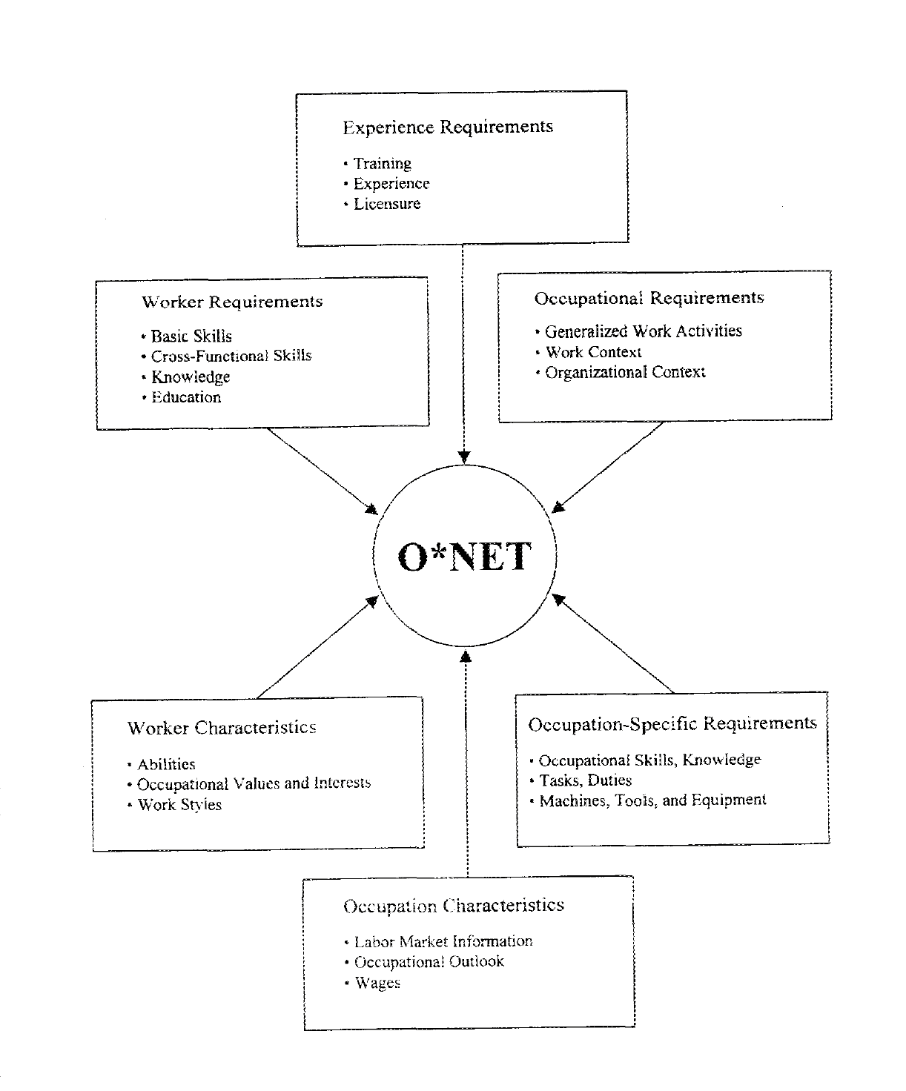
The O*Net Content Model
    - It contains multiple levels of information, so it can be used for many different purposes
      - It has information about individual level features that are needed to do a job
        - Worker Requirements: “general attributes that are developed through education and experience… they include knowledge, skills, and education.” (Peterson et al., 2001, p. 463).
        - Experience Requirements: “the types and quantities of experience that are required in a specific occupation, including incumbent experience in other jobs, job-related training, on the job training, and licensure or certification requirements.” (Peterson et al., 2001, p. 471-472).
        - Worker Characteristics: “relatively enduring individual attributes that influence the capacities they can ultimately develop as well as their willingness to engage in certain kinds of activities.” (Peterson et al., 2001, p. 457).
      - It has information on job-level features
        - Occupational Requirements: “descriptors of the work itself, as compared to descriptors of the worker… the work activities and context within which the work is performed.” (Peterson et al., 2001, p. 467).
        - Occupation-Specific Requirements: Tasks, duties, and skills specific to a single job.
          - This information must be collected for the specific job. O*NET suggests a procedure for how to collect the information.
      - It has information about the types of organizations where the job is done.
        - Organizational Context: “Characteristics of the organization that affect all jobs within that organization.” (Peterson et al., 2001, p. 471).
      - It has economic information about the job.
        - Occupation Characteristics: Information about labor demand, labor supply, and other labor market information.
    - O*NET is available on the internet at www.onetcenter.org
- Two new trends in job analysis (and related areas).
  - Competency Modeling: A technique popularized in business, designed to identify the “core competencies” that are necessary for a person to be a successful part of an organizations goals.
    - This is similar to job analysis, but it is usually
      - More focused on a close connection between the individual competency requirements and the broader goals of the organization
      - More focused on the things that jobs or occupations within an organization have in common, as opposed to identifying the differences between jobs.
      - More likely to identify broad level descriptors.
    - On the down-side
      - the broadness of the descriptors sometimes means that competency models for any job sound alike. Especially because …
      - There is no clear-cut definition of what is meant by the term “core competency.”
  - Cognitive Task Analysis: An emphasis on finding the actual mental processes or activities used by experts to complete the job...
    - For example, in a task-based analysis of the job pilot, we might have the task “Determine current location.”
      - A worker-based analysis might include related skills or abilities: “Knowldege of maps & compasses”, “visual acuity”, “visualization ability”.
      - A Cognitive task analysis would attempt to determine which of many ways to work out current location is being used by expert pilots, and how that would differ from non-experts.
    - Uses techniques and concepts from cognitive psychology.
    - Can be time consuming and expensive.

As mentioned in the very beginning, job analysis is a crucial part of almost every human resource function. We will talk about it a lot as we go through the next couple of parts of the class. It’s important to keep the ideas about what job analysis is in mind as we proceed.

